Submitted on time? (YES/ NO):

**Task 01**: Complete the Table 01. **40 points**

**Task 02:** Attach screenshots of the simulated circuit of the experiment showing all Multimeter/ simulation readings as mentioned in the class. **30 points**

**Task -03:** Discuss your observation from this experiment in brief. **30 points**

**NOTE**: You must submit PDF of this file

**Name & ID:** Md. Rifat Ahmed ~ 1931725042

**Task: 01**

Vs = 10V(p-p).

Table 01

|  |  |  |  |  |  |  |
| --- | --- | --- | --- | --- | --- | --- |
| **(Vb)** | Vo (p-p) | | | | | |
| Fig 4.6 | | Fig 4.7 | | Fig 4.8 | |
| (a) | (b) | (a) | (b) | (a) | (b) |
| 0 | 4.37V |  | 5.63V |  | 10.6V |  |
| 1 | 3.37V |  | 6.63V |  | 10.4V |  |
| 2 | 2.38V |  | 7.62V |  | 10.3V |  |
| **2.5** | 1.89V |  | 8.11V |  | 10.3V  Vmax= -1.53V  Vmin= -11.8V | Vmax=  Vmin= |
| 3 | 1.4V |  | 8.6V |  | 10.3V |  |
| 4 | 426mV |  | 9.57V |  | 10.3V |  |
| 5 | 0V |  | 10V |  | 10.3V |  |

**Task: 02**

Attach the screenshots of the simulated circuits with i/o waveforms below:

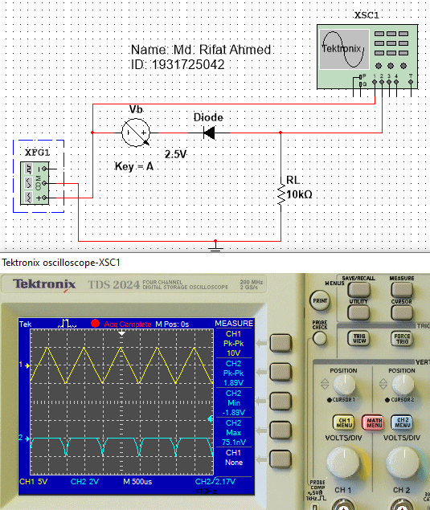

Figure 1: Series Clipper Circuit (Fig 4.6 (a))

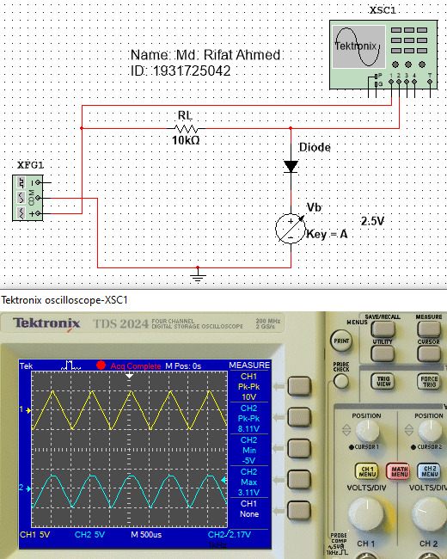

Figure 2: Parallel Clipper Circuit (Fig 4.7 (a))

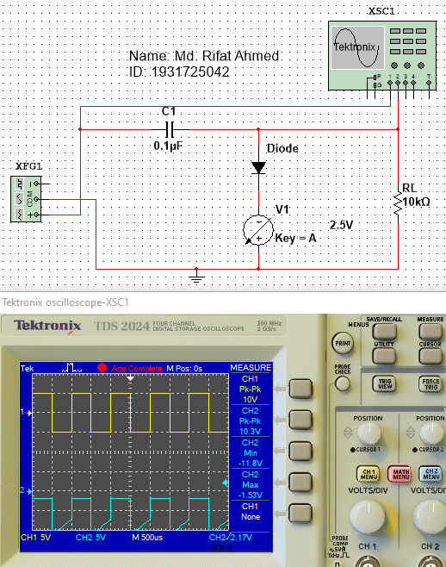

Figure 3: Clamper Circuit (Fig 4.8 (a))

Attach only waveforms below:

*[Take screenshots of input/ output waveforms of each simulated circuits]*

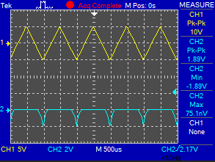

Figure 4: Input-Output Waveform of Fig 1

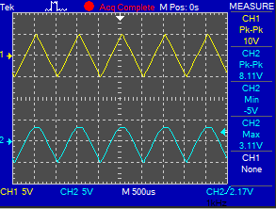

Figure 5: Input-Output Waveform of Fig 2

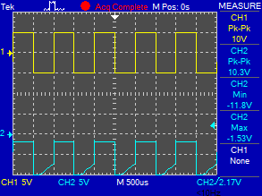

Figure 6: Input-Output Waveform of Fig 3

**Task: 03**

**Observation:**

In this experiment we learnt about series clipper circuit, parallel clipper circuit and clamper circuit. Clipper circuits are those that remove signal voltage above and below a specified level on the other hand a DC clamper circuit adds a voltage to the input signal. So, to construct a series clipper circuit we took a DC interactive voltage source and connected it in reverse bias with the virtual diode and then a 10kΩ resistor. To calculate the output, we used Tektronix oscilloscope like we used in the previous lab. Now, for the series clipper circuit as we increased the voltage of Vb the output voltage started decreasing and at 10V we got the peak to peak output as 0V. Then for the parallel clipper circuit we took a 10kΩ resistor first then took a forward bias virtual diode then connected it to the positive pole of the voltage source. For this circuit we got a smooth curve and 10V we got the peak to peak voltage 10V. Finally coming to the clamper circuit, we took a 0.1µF capacitor then took our forward bias virtual diode then connected the negative pole of the voltage source and added the 10kΩ resistor in parallel with the whole circuit. In this circuit we had to change the graph shape to squared waveform and for this circuit the output voltage were almost the same the whole time as we increased our input voltage.